**How to Search for Classes**

**Step 1: Access your Student Portal**



**Step 2: Click on the 3 bars in the upper-right hand corner, select Records & registration:**

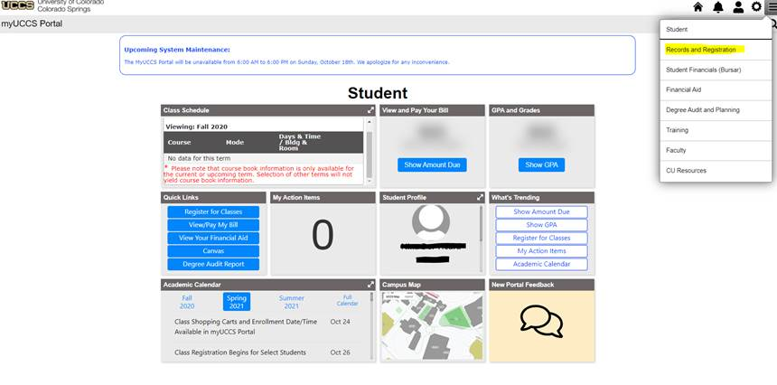

**Step 3: Click on Access Student Self Service**

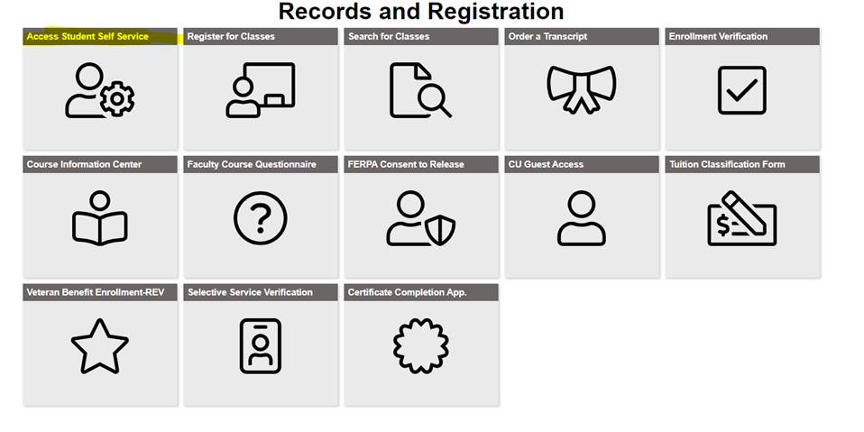

**Step 4:** **Select Register For Classes (Add/Drop):**

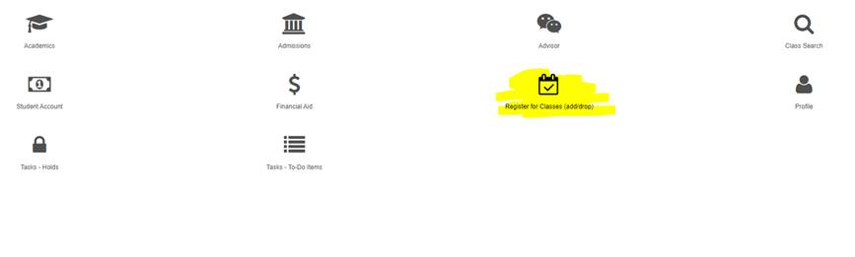**Step 5: Select Class Search**

