**How to Check if You Have Holds on Your Account**

**Step 1: Access your Student Portal**

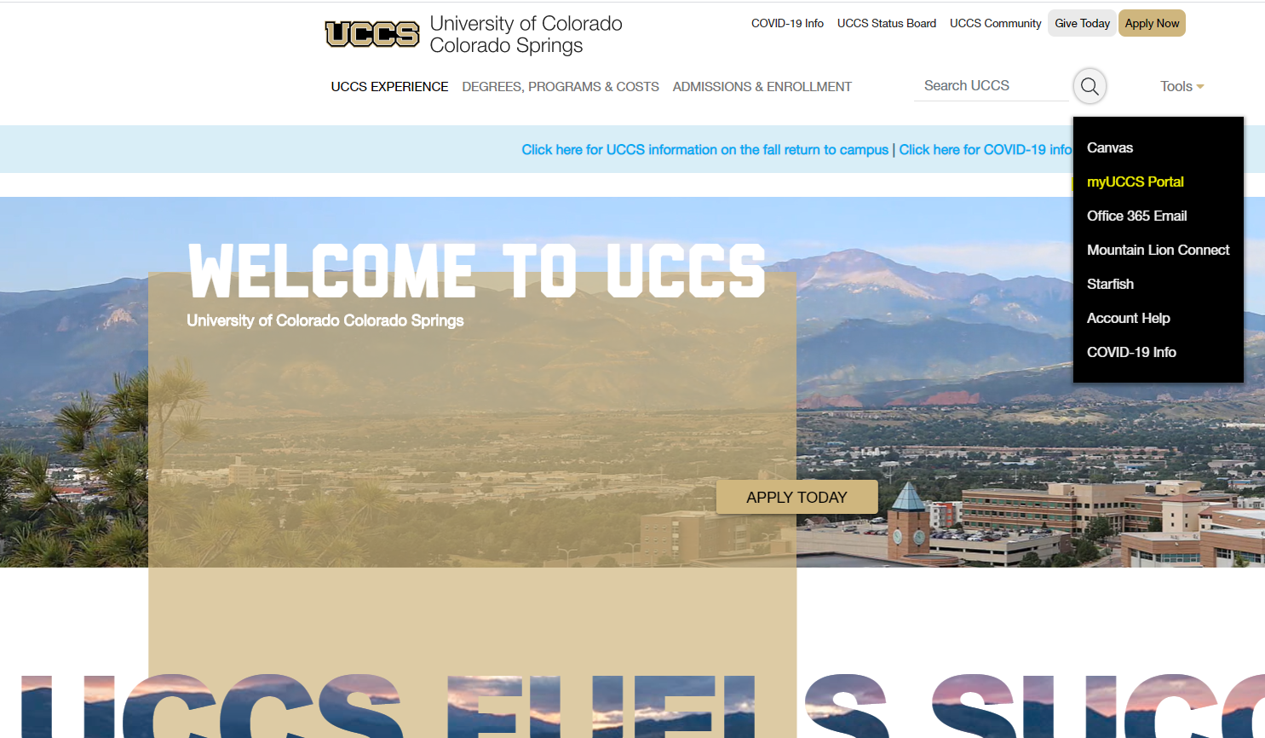

**Step 2: Click on the 3 bars in the upper-right hand corner, select Records & registration:**

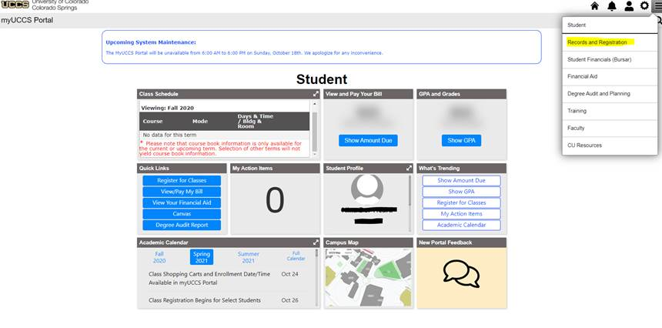

**Step 3: Click on Access Student Self Service**

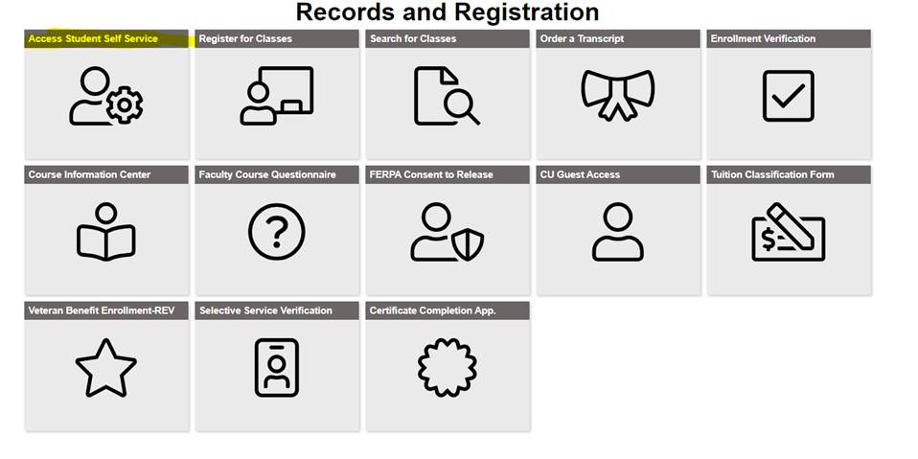

**Step 4: Check Holds & To Do Items**

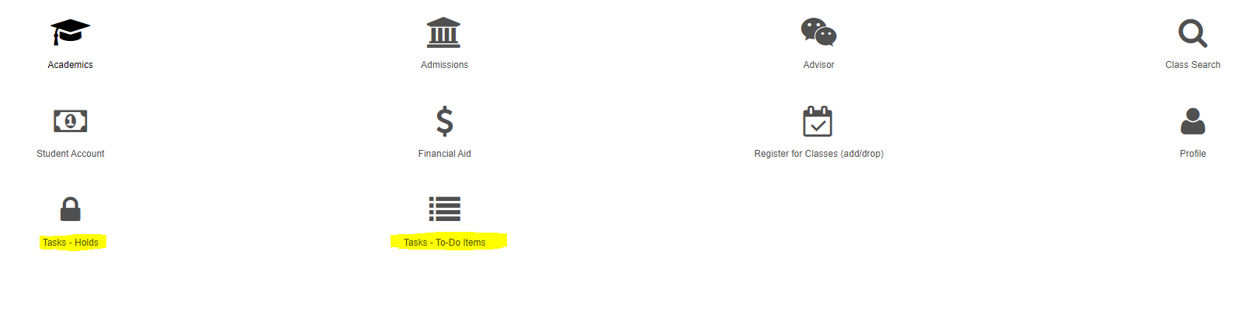

1. **First check Holds, it will tell you what hold(s) (if any) you have on your account**
2. **Then, check To Do Items as it will tell you who put the hold(s) on and how to resolve them**